**Enhancing Cloud Organization Classification in Climate Models using DenseNet-169: Towards Reduced Uncertainties and Improved Climate Projections**

|  |  |
| --- | --- |
| **ZAYYAM FIDA** | **21032133** |

**SUBMITTED BY:**

**INTRODUCTION**

In contemporary discussions and political decision-making, climate change issues have taken center stage. Many companies are now deeply concerned about their environmental impact and the potential effects of their by-products. As a result, stringent standards have been introduced to protect nature and mitigate climate change. Failure to adhere to these standards can lead not only to public criticism but also to substantial fines. Consequently, there is an increasing demand for analyzing and understanding climate patterns in order to ensure their stability. Understanding the behaviorr of clouds is a crucial aspect of modeling Earth's climate. However, investigating cloud behavior poses significant challenges, as it necessitates a comprehensive comprehension of the underlying atmospheric processes. To enhance our understanding of clouds, researchers aim to classify different types of cloud formations, thereby improving the physical understanding of these phenomena and facilitating the development of more accurate climate models. At the Max Planck Institute for Meteorology, a dataset was compiled by collecting approximately 10,000 Terra and Aqua MODIS visible images, covering an area of approximately 21°×14° (longitude-latitude), from NASA Worldview. Through the collaboration of the Zooniverse crowd-sourced community, this dataset was annotated with four distinct cloud types: Sugar, Fish, Gravel, and Flower [1]. Due to the presence of significant noise in the annotation process, researchers are seeking a robust and widely applicable solution to accurately classify and segment different types of cloud formations in unseen images. The goal is to develop a stable and well-generalized approach that can effectively handle the challenges posed by variations in image quality and annotation inconsistencies. By achieving this, researchers aim to enhance the reliability and accuracy of classifying and segmenting cloud types in previously unobserved images. In contrast to rule-based methods, which have shown limited success in classifying and segmenting cloud types, machine learning approaches offer a promising solution. Convolutional neural networks (CNNs) have demonstrated their effectiveness in various domains of computer vision, including classification and segmentation tasks. Leveraging the power of CNNs, researchers can tap into their ability to automatically learn and extract relevant features from cloud images, enabling more accurate classification and segmentation of different cloud types. This application of machine learning techniques holds great potential for advancing our understanding of cloud formations and improving the accuracy of their analysis [2].

**ABOUT DATASET**

The Max Planck Institute for Meteorology is conducting research to enhance our understanding of shallow clouds and their impact on Earth's climate. Cloud organization patterns play a crucial role in climate models, but accurately classifying these patterns is challenging. To address this, a competition has been launched to develop a model that can classify different types of cloud organization from satellite images. By leveraging the human eye's ability to detect features like cloud formations resembling flowers, the model aims to improve our understanding of clouds and enable the development of more accurate climate models. The ultimate goal is to reduce uncertainties in climate projections and contribute to shaping a better understanding of our future climate [3].

**EXPLORATORY ANALYSIS OF THE DATASET**

In an exploratory analysis of the dataset, the researchers would initially assess the attributes of the satellite images and the provided details on cloud organization patterns. They would delve into examining how different types of cloud formations are distributed and how they vary across time and geographical regions. To gain insights from the dataset, the researchers would employ diverse statistical measures and visualizations.Fig.1 shows training and testing data in the dataset while Fig.2 Shows different occurrences of data in the dataset. The researchers would also explore image processing techniques to extract relevant features from the satellite images. This could involve 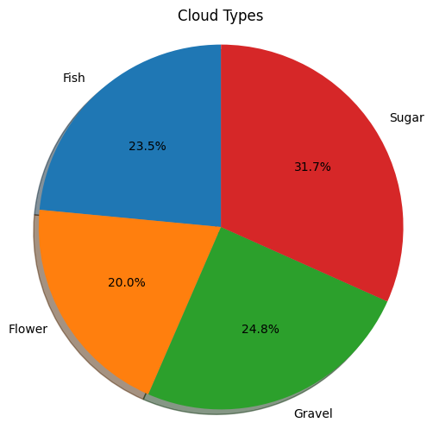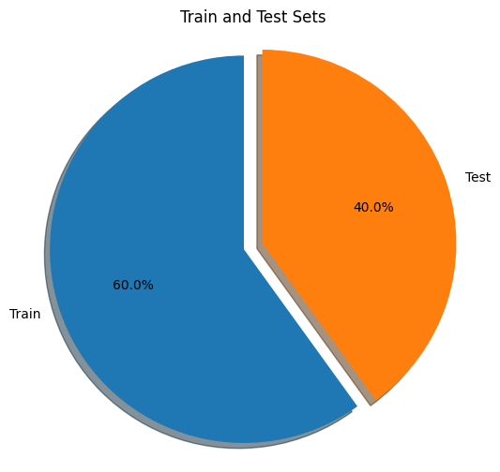studying the shapes, textures, and colors of clouds to identify distinct patterns and categorize them accordingly.

Fig.1 Shows Training and testing data Fig.2 Shows different occurrences of data

**HEATMAP OF DATASET**

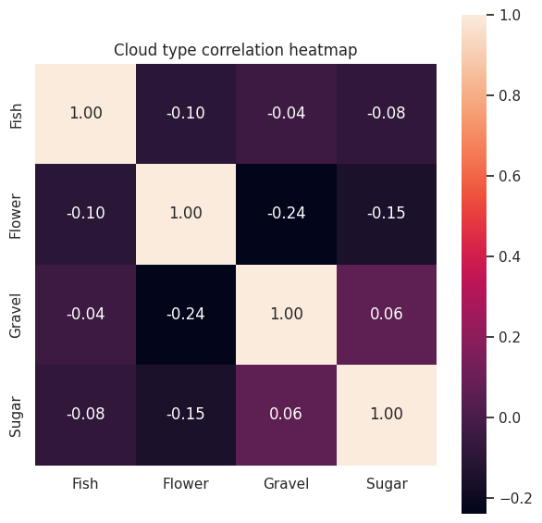Heatmaps are highly effective visual representations that facilitate the exploration and interpretation of intricate data patterns. By utilizing color gradients to depict data values, heatmaps enable efficient analysis of complex information in a visually meaningful way. They are widely used for identifying trends, clusters, and variations within datasets, making them a valuable tool for gaining insights from data. Blow table show image and their labels while another diagram shows a heatmap of the dataset.

**SEGMENTING REGIONS WITHIN A TRAINING DATASET**

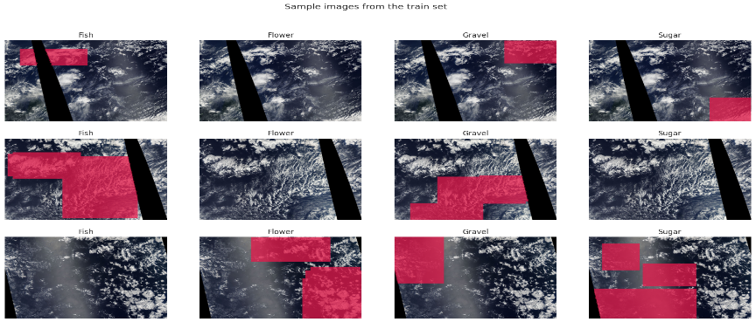Accurately segmenting regions within an image dataset is of utmost importance in a range of applications such as object detection, image recognition, medical imaging, and scene understanding. This process allows researchers to identify and delineate regions of interest with precision, facilitating the extraction of meaningful information from the images. Fig.3. Shows training data along with segmenting region. By achieving accurate segmentation, more advanced analyses and applications can be performed, enhancing our understanding and utilization of the image data [4].

Fig.3 Shows training data along with segmented region

**KERNEL DENSITY ESTIMATION (KDE)**

Kernel Density Estimation (KDE) is a statistical technique that estimates the probability density function of continuous data. It utilizes kernel functions centered at data points and sums them to create a smooth curve representing the distribution. KDE is especially useful when the true distribution is unknown or data is limited. It uncovers significant features like modes, peaks, and density variations. KDE finds applications in data analysis, pattern recognition, and data visualization, aiding in understanding data distribution and informing decision-making processes.Fig.4. Shows KDE of dataset [5].

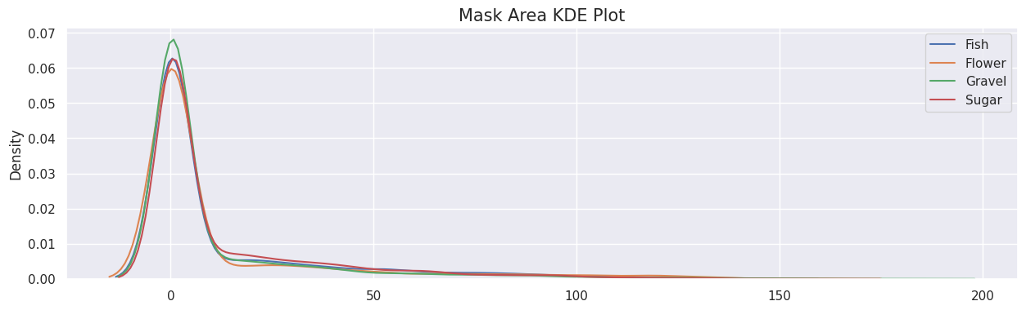

Fig.4. Shows the KDE plot

**Model DenseNet-169:** DenseNet-169, an advanced convolutional neural network architecture, excels in image classification tasks. It builds upon the original DenseNet model by incorporating densely connected layers, which enable effective feature reuse and gradient propagation. Each dense block within DenseNet-169 contains densely connected convolutional layers, facilitating direct access to earlier layers' feature maps. This dense connectivity empowers the network to learn efficiently while maintaining a compact parameter count. DenseNet-169 has proven its superiority in computer vision applications, achieving state-of-the-art performance on established datasets. Its exceptional ability to capture intricate details and handle complex visual patterns has positioned it as a preferred choice for accurate and reliable image classification [6].

**Adaptive Moment Estimation Optimizer:** Adam (Adaptive Moment Estimation) is a widely used optimization algorithm in deep learning for efficient model training. It combines adaptive learning rates and momentum to optimize parameters effectively. By maintaining separate learning rates for each parameter and using gradient moments, Adam adapts the learning rates to different regions of the loss landscape, leading to faster convergence. It also incorporates momentum to enhance convergence speed and handle complex architectures. Compared to traditional optimization methods, Adam requires fewer hyperparameter tunings and is suitable for large-scale models [7].

**SIGMOID ACTIVATION FUNCTION:** The sigmoid activation function, also known as the logistic function, is widely used in neural networks. It transforms input values into a range of probabilities between 0 and 1, representing the likelihood of a binary outcome. The mathematical formula for the sigmoid function is f(x) = 1 / (1 + exp(-x)), where 'x' represents the input. This formula applies an exponential function to the input, normalizing it and allowing for non-linear transformations. By using the sigmoid activation function, neural networks can capture complex relationships and make predictions based on probabilities [8].

|  |  |
| --- | --- |
| **Loss:** | 0.862456738948822 |
| **IoU:** | 0.36750343441963196 |
| **F1:** | 0.5084342360496521 |

**Table.1 Performance of DenseNet-169 model on Dataset**

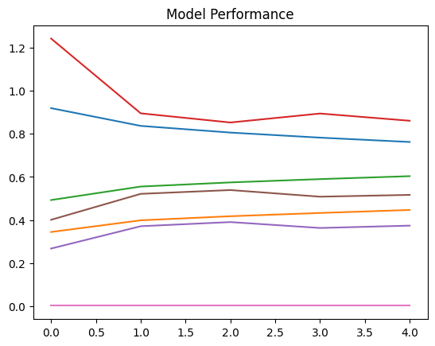

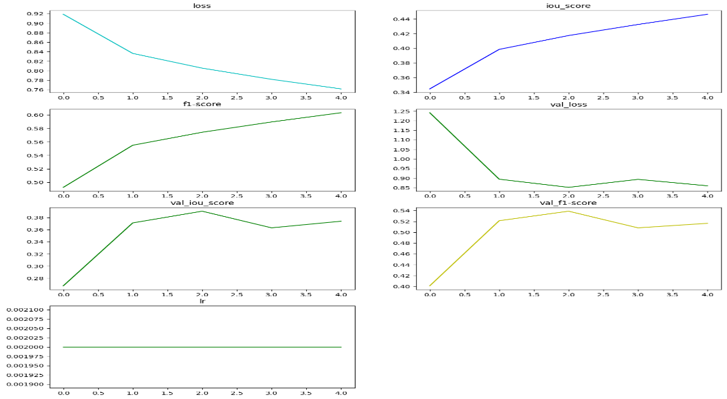

**Critical Analysis**

My assignment utilizing the DenseNet-169 architecture and the Adaptive Moment Estimation optimizer for classifying cloud organization patterns has shown potential for improvement. While there has been progress with a loss value of 0.862 and an F1 score of 0.508, the model struggles with accurately identifying different cloud patterns, as indicated by the IoU score of 0.367. To enhance my assignment, it is recommended to focus on refining data preprocessing techniques, optimizing the model, employing regularization methods, augmenting the dataset, and conducting thorough model evaluations. Experimenting with hyperparameters, incorporating regularization techniques, expanding the dataset through augmentation, and considering ensemble methods can contribute to improving the model's performance. Seeking feedback from domain experts will provide valuable insights and guidance for further enhancements in my assignment.

**Results and Future Work**

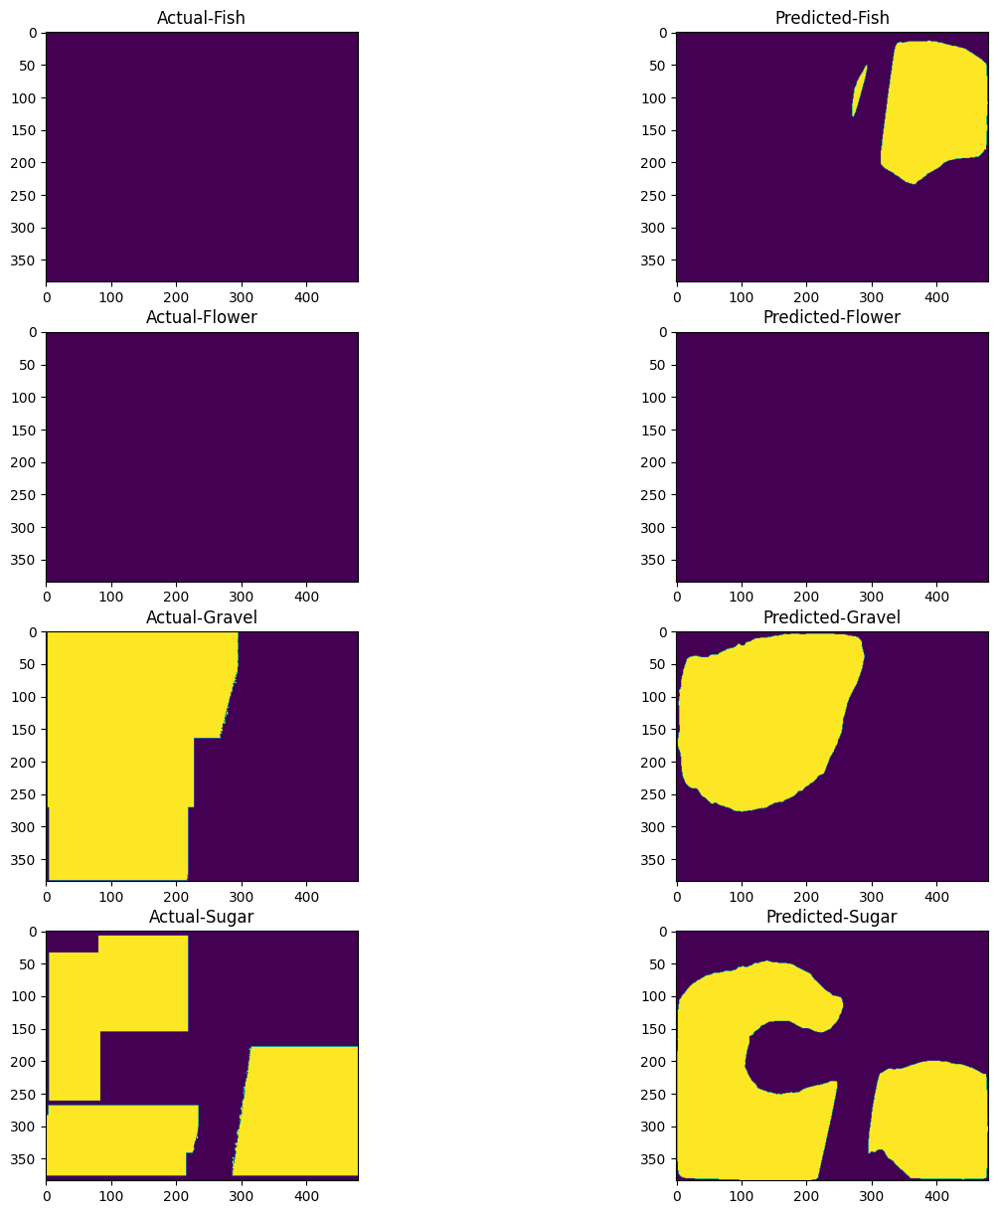The DenseNet-169 model performs exceptionally well when presented with an actual image, yielding accurate predictions. This success can be attributed to the model's advantageous architecture, which includes dense connections that enable efficient feature reuse. By leveraging these interconnected layers, the model effectively captures intricate details and complex patterns within the image. As a result, the predicted output aligns closely with the true label of the actual image result shown in Fig.5

Fig.5. Shows the image and predicted results

**FUTURE WORK**

In future Workresearch, the classification of different cloud organization patterns using the DenseNet-169 model can be enhanced through various approaches. These include fine-tuning and transfer learning, applying data augmentation techniques, optimizing model parameters, exploring ensemble methods, and investigating interpretability and visualization techniques. By pursuing these avenues, researchers can improve the model's performance, achieve higher accuracy in classifying cloud organization patterns, and contribute to a better understanding of clouds. This, in turn, can lead to improvements in climate models, reducing uncertainties in climate projections and enhancing our knowledge of Earth's climate system.

Google Colab link :

[**https://colab.research.google.com/drive/1ZCmZW4XT6EIdkaTan6IjpsJ5udvpOZLp?usp=sharing#scrollTo=9iZxVg0SNmt7**](https://colab.research.google.com/drive/1ZCmZW4XT6EIdkaTan6IjpsJ5udvpOZLp?usp=sharing#scrollTo=9iZxVg0SNmt7)

**GitHub LINK:**

**https://github.com/zayyamffida123/My-assignment-**

**References:**

1. Rasp, S., Schulz, H., Bony, S., & Stevens, B. (2020). Combining crowdsourcing and deep learning to explore the mesoscale organization of shallow convection. *Bulletin of the American Meteorological Society*, *101*(11), E1980-E1995.
2. Tymchenko, B., Marchenko, P., & Spodarets, D. (2020). Segmentation of cloud organization patterns from satellite images using deep neural networks. *Herald of Advanced Information Technology*, *1*(3), 352-361.
3. Stevens, B., Bony, S., Brogniez, H., Hentgen, L., Hohenegger, C., Kiemle, C., ... & Zuidema, P. (2020). Sugar, gravel, fish and flowers: Mesoscale cloud patterns in the trade winds. *Quarterly Journal of the Royal Meteorological Society*, *146*(726), 141-152.
4. Jha, D., Smedsrud, P. H., Riegler, M. A., Halvorsen, P., de Lange, T., Johansen, D., & Johansen, H. D. (2020). Kvasir-seg: A segmented polyp dataset. In *MultiMedia Modeling: 26th International Conference, MMM 2020, Daejeon, South Korea, January 5–8, 2020, Proceedings, Part II 26* (pp. 451-462). Springer International Publishing.
5. Chen, Y. C. (2017). A tutorial on kernel density estimation and recent advances. *Biostatistics & Epidemiology*, *1*(1), 161-187.
6. Senousy, Z. (2023). *Medical Image Classification using Deep Learning Techniques and Uncertainty Quantification* (Doctoral dissertation, Birmingham City University).
7. Attrapadung, N., Hamada, K., Ikarashi, D., Kikuchi, R., Matsuda, T., Mishina, I., ... & Schuldt, J. C. (2021). Adam in private: Secure and fast training of deep neural networks with adaptive moment estimation. *arXiv preprint arXiv:2106.02203*.
8. Pratiwi, H., Windarto, A. P., Susliansyah, S., Aria, R. R., Susilowati, S., Rahayu, L. K., ... & Rahadjeng, I. R. (2020, February). Sigmoid activation function in selecting the best model of artificial neural networks. In *Journal of Physics: Conference Series* (Vol. 1471, No. 1, p. 012010). IOP Publishing.